第三章 ABAP 语法示例

3.1 FIELD-SYMBOLS

FIELD-SYMBOLS 是字段符号，类似于 FOXPRO 的宏，FOXPRO 能把一段程序存入一
个字符串中，再通过某种方式使该字符串运行。SAP 的 FIELD-SYMBOLS，把一个结构定
义分配给字段符号，通过字段符号来引用结构中的成员。
【例 3.1】
REPORT YTEST001.

DATA:BEGIN OF MAN,
NAME(30) TYPE C,
HIGH TYPE P DECIMALS 2,
WEIGHT TYPE P DECIMALS 2,
END OF MAN.

FIELD-SYMBOLS <FSA> LIKE MAN.
DATA MAN1 LIKE MAN.

MAN1-NAME = '张林'.
MAN1-HIGH = '1.78'.
MAN1-WEIGHT = 140.

ASSIGN MAN1 TO <FSA>.
WRITE: / <FSA>-NAME,
<FSA>-HIGH,
<FSA>-WEIGHT.

输出结果如图 3-1 所示。

图 3-1

3.2 字符串处理

3.2.1 合并字符串

【例 3.2】
REPORT YTEST001.


DATA: C1(2) TYPE C,
C2(2) TYPE C,
C3(2) TYPE C,
C4(2) TYPE C,
C5(20) TYPE C,
C9(2) TYPE C.

C1 = 'AB'.
C2 = 'CD'.
C3 = 'EF'.
C4 = 'GH'.
C9 = '+'.
CONCATENATE C1 C2 C3 C4 INTO C5.
WRITE C5.
CONCATENATE C1 C2 C3 C4 INTO C5 SEPARATED BY C9.
WRITE / C5.
输出结果如图 3-2 所示。

图 3-2
本例中，先将字符串 C1、C2、C3、C4 合并到字符串 C5，再将字符串 C1、C2、C3、C4 用
间隔符字符串 C9 合并到字符串 C5。

3.2.2 拆分字符串

【例 3.3】
REPORT YTEST001.
DATA: C1(2) TYPE C,
C2(2) TYPE C,
C3(2) TYPE C,
C4(2) TYPE C,
C5(20) TYPE C VALUE '11 * 22 * 33 * 44',
C9(2) TYPE C.

C9 = '*'.
WRITE C5.
SPLIT C5 AT C9 INTO C1 C2 C3 C4.
WRITE: / C1, C2, C3, C4.
输出结果如图 3-3 所示。


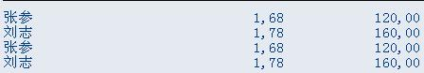

3.3 内表带有标题行

【例 3.4】
REPORT YTEST001.
DATA: BEGIN OF MAN,
NAME(20) TYPE C,
HIGH TYPE P DECIMALS 2,
WEIGHT TYPE P DECIMALS 2,
END OF MAN.

图 3-3

DATA: MAN1 LIKE TABLE OF MAN WITH HEADER LINE,
MAN2 LIKE TABLE OF MAN.

MAN-NAME = '张参'.
MAN-HIGH = '1.68'.
MAN-WEIGHT = 120.
APPEND MAN TO MAN1.

MAN-NAME = '刘志'.
MAN-HIGH = '1.78'.
MAN-WEIGHT = 160.
APPEND MAN TO MAN1.

MOVE MAN1[] TO MAN2.

LOOP AT MAN2 INTO MAN.
WRITE: / MAN-NAME,MAN-HIGH, MAN-WEIGHT.
ENDLOOP.

LOOP AT MAN1.
WRITE: / MAN1-NAME,MAN1-HIGH,MAN1-WEIGHT.
ENDLOOP.
本例中内表 MAN1 有表头，内表 MAN2 无表头，输出结果一样，如图 3-4 所示。

图 3-4

3.4 内表排序

【例 3.5】
REPORT YTEST001.

DATA: BEGIN OF MAN,
NAME(20) TYPE C,
HIGH TYPE P DECIMALS 2,
WEIGHT TYPE P DECIMALS 2,
END OF MAN.
DATA: MAN1 LIKE HASHED TABLE OF MAN WITH UNIQUE KEY NAME.

MAN-NAME = '张参'.
MAN-HIGH = '1.68'.
MAN-WEIGHT = 120.
INSERT MAN INTO TABLE MAN1.

MAN-NAME = '刘志'.
MAN-HIGH = '1.78'.
MAN-WEIGHT = 160.
INSERT MAN INTO TABLE MAN1.

MAN-NAME = '朱强'.
MAN-HIGH = '1.72'.
MAN-WEIGHT = 130.
INSERT MAN INTO TABLE MAN1..

LOOP AT MAN1 INTO MAN.
WRITE: / MAN-NAME,MAN-HIGH, MAN-WEIGHT.
ENDLOOP.

SORT MAN1 DESCENDING BY WEIGHT ASCENDING.
SKIP.
ULINE.
LOOP AT MAN1 INTO MAN.
WRITE: / MAN-NAME,MAN-HIGH,MAN-WEIGHT.
ENDLOOP.
输出结果如图 3-5 所示。

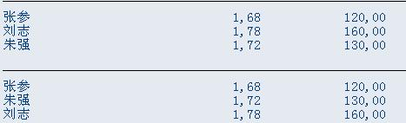

3.5 修改内表数据

【例 3.6】
REPORT YTEST001.

DATA: BEGIN OF MAN,
NAME(20) TYPE C,
HIGH TYPE P DECIMALS 2,
WEIGHT TYPE P DECIMALS 2,
END OF MAN.

图 3-5

DATA: MAN1 LIKE HASHED TABLE OF MAN WITH UNIQUE KEY NAME.

MAN-NAME = '张参'.
MAN-HIGH = '1.68'.
MAN-WEIGHT = 120.
INSERT MAN INTO TABLE MAN1.

MAN-NAME = '刘志'.
MAN-HIGH = '1.78'.
MAN-WEIGHT = 160.
INSERT MAN INTO TABLE MAN1.

LOOP AT MAN1 INTO MAN.
WRITE: / MAN-NAME,MAN-HIGH, MAN-WEIGHT.
ENDLOOP.

MAN-NAME = '张参'.
MAN-HIGH = '2.22'.
MAN-WEIGHT = 220.
MODIFY TABLE MAN1 FROM MAN.

LOOP AT MAN1 INTO MAN.
WRITE: / MAN-NAME,MAN-HIGH,MAN-WEIGHT.
ENDLOOP.



本例根据关键字修改内表，输出结果如图 3-6 所示。

图 3-6

3.6 删除内表记录

【例 3.7】
REPORT YTEST001.

DATA: BEGIN OF MAN,
NAME(20) TYPE C,
HIGH TYPE P DECIMALS 2,
WEIGHT TYPE P DECIMALS 2,
END OF MAN.
DATA: MAN1 LIKE HASHED TABLE OF MAN WITH UNIQUE KEY NAME.

MAN-NAME = '张参'.
MAN-HIGH = '1.68'.
MAN-WEIGHT = 120.
INSERT MAN INTO TABLE MAN1.

MAN-NAME = '刘志'.
MAN-HIGH = '1.78'.
MAN-WEIGHT = 160.
INSERT MAN INTO TABLE MAN1.

LOOP AT MAN1 INTO MAN.
WRITE: / MAN-NAME,MAN-HIGH, MAN-WEIGHT.
ENDLOOP.

DELETE MAN1 WHERE NAME = '张参'.
SKIP.
ULINE.
LOOP AT MAN1 INTO MAN.
WRITE: / MAN-NAME,MAN-HIGH,MAN-WEIGHT.
ENDLOOP.
输出结果如图 3-7 所示。

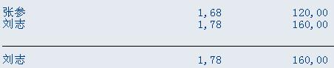

3.7 使用索引插入内表行

【例 3.8】
REPORT YTEST001.

DATA: BEGIN OF MAN,
NAME(20) TYPE C,
HIGH TYPE P DECIMALS 2,
WEIGHT TYPE P DECIMALS 2,
END OF MAN.
DATA: MAN1 LIKE TABLE OF MAN.

MAN-NAME = '张参'.
MAN-HIGH = '1.68'.
MAN-WEIGHT = 120.
INSERT MAN INTO TABLE MAN1.

MAN-NAME = '刘志'.
MAN-HIGH = '1.78'.
MAN-WEIGHT = 160.
INSERT MAN INTO TABLE MAN1.

LOOP AT MAN1 INTO MAN.

图 3-7

WRITE: / MAN-NAME,MAN-HIGH, MAN-WEIGHT.
ENDLOOP.

MAN-NAME = '李志'.
MAN-HIGH = '1.58'.
MAN-WEIGHT = 110.
INSERT MAN INTO MAN1 INDEX 2.
ULINE.

LOOP AT MAN1 INTO MAN.
WRITE: / MAN-NAME,MAN-HIGH,MAN-WEIGHT.
ENDLOOP.
输出结果如图 3-8 所示。

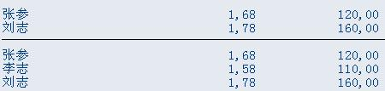

3.8 格式化输出

【例 3.9】
REPORT YTEST001.
DATA WA LIKE SPFLI.
WRITE: /.

图 3-8

WRITE: 10'航班承运人',40'航班连接',60'国家代码',80'起飞城市',100'起飞机场'.

SELECT * INTO WA FROM SPFLI.
WRITE: / WA-CARRID UNDER '航班承运人',
WA-CONNID UNDER '航班连接',
WA-COUNTRYFR UNDER '国家代码',
WA-CITYFROM UNDER '起飞城市',
WA-AIRPFROM UNDER '起飞机场'.

ENDSELECT.

本例通过 UNDER 定位输出位置，输出结果如图 3-9 所示。

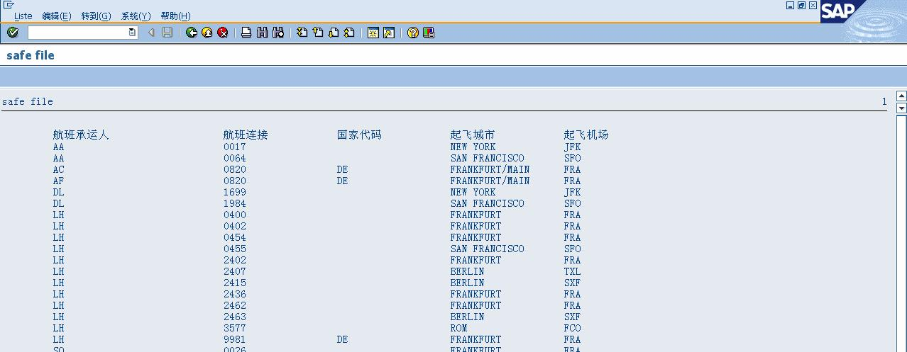
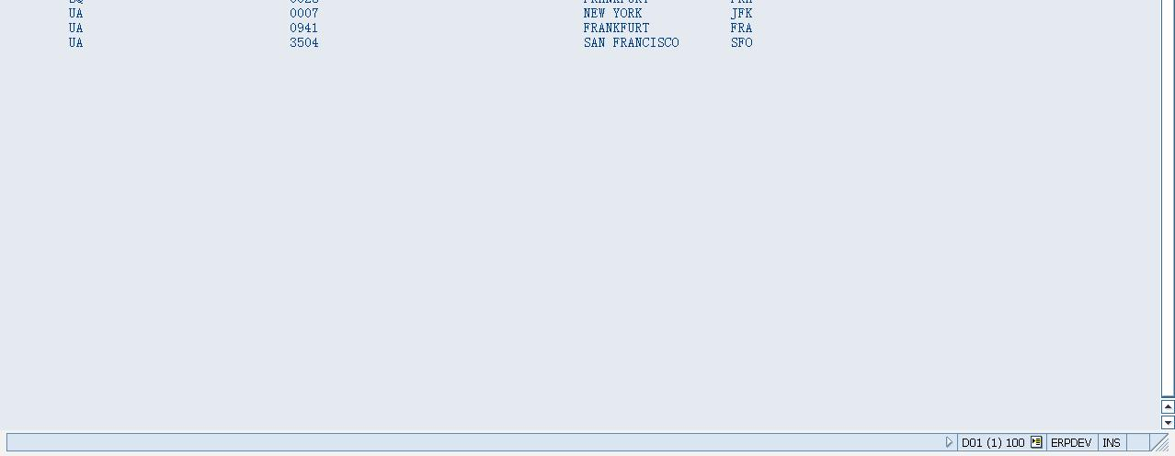

3.9 内部数据存为文件

【例 3.10】
REPORT YTEST001.

DATA: BEGIN OF MAN,
NAME(20) TYPE C,
HIGH TYPE P DECIMALS 2,
WEIGHT TYPE P DECIMALS 2,
END OF MAN.
DATA: MAN1 LIKE TABLE OF MAN.

图 3-9

DATA: NAME TYPE RLGRAP-FILENAME, TYPA TYPE RLGRAP-FILETYPE.

MAN-NAME = '张参'.
MAN-HIGH = '1.68'.
MAN-WEIGHT = 120.
INSERT MAN INTO TABLE MAN1.

MAN-NAME = '刘志'.
MAN-HIGH = '1.78'.
MAN-WEIGHT = 160.

INSERT MAN INTO TABLE MAN1.

MAN-NAME = '李志'.
MAN-HIGH = '1.58'.
MAN-WEIGHT = 110.
INSERT MAN INTO MAN1 INDEX 2.

NAME = 'C:\TEMP\TESTA.TXT'.
TYPA = 'DAT'.

CALL FUNCTION 'DOWNLOAD'
EXPORTING
CODEPAGE = 'TESTA'
FILENAME = NAME
FILETYPE = TYPA
ITEM = '文件测试'
TABLES
DATA_TAB = MAN1
EXCEPTIONS
INVALID_FILESIZE = 1
INVALID_TABLE_WIDTH = 2
INVALID_TYPE = 3
NO_BATCH = 4
UNKNOWN_ERROR = 5
GUI_REFUSE_FILETRANSFER = 6
OTHERS = 7.
IF SY-SUBRC <> 0.
* MESSAGE ID SY-MSGID TYPE SY-MSGTY NUMBER SY-MSGNO
* WITH SY-MSGV1 SY-MSGV2 SY-MSGV3 SY-MSGV4.
ENDIF.
打开运行实例存储文件，有以下内容：

张参
李志
刘志
1,68
1,58
1,78

3.10 直接存入文件

【例 3.10】
REPORT YTEST001.

DATA: BEGIN OF MAN,
NAME(20) TYPE C,
HIGH TYPE P DECIMALS 2,

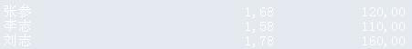

WEIGHT TYPE P DECIMALS 2,
END OF MAN.
DATA: MAN1 LIKE TABLE OF MAN.

CALL FUNCTION 'UPLOAD'
EXPORTING
CODEPAGE = 'TEST'
FILENAME = 'C:\TEMP\TESTA.TXT'
FILETYPE = 'DAT'
ITEM = '读放文件'
TABLES
DATA_TAB = MAN1
EXCEPTIONS
CONVERSION_ERROR = 1
INVALID_TABLE_WIDTH = 2
INVALID_TYPE = 3
NO_BATCH = 4
UNKNOWN_ERROR = 5
GUI_REFUSE_FILETRANSFER = 6
OTHERS = 7.
IF SY-SUBRC <> 0.
* MESSAGE ID SY-MSGID TYPE SY-MSGTY NUMBER SY-MSGNO
* WITH SY-MSGV1 SY-MSGV2 SY-MSGV3 SY-MSGV4.
ENDIF.

LOOP AT MAN1 INTO MAN.
WRITE: / MAN-NAME,MAN-HIGH, MAN-WEIGHT.
ENDLOOP.
输出结果如图 3-10 所示。

图 3-10

3.12 不使用提示框提示直接读入文件

在例 3.11 中，程序运行时弹出输入读入文件名的提示框（如图 3-10 示），将程序中“CALL
FUNCTION ‘UPLOAD’”改为“CALL FUNCTION ‘WS——UPLOAD’”，程序运行时将
不再提示直接读入文件。

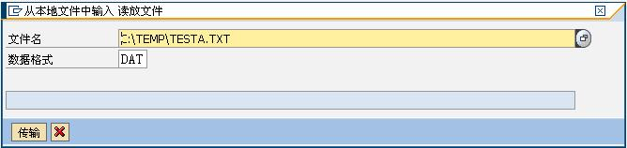

3.13 列表输出

WRITE 语法
WRITE AT [/] [<pos>] [(<len>)] 文本
“/”： 下一行
“pos”： 列
“（len）”：长度
【例 3.10】
REPORT YTEST001.

图 3-11

DATA: STR1(10) TYPE C VALUE 'AABBCCDDEE'.
WRITE '接着的字符串____________将被替换.'.
WRITE AT 14(10) STR1.
输出结果如图 3-11 所示。

图 3-12

